# OpenManage Storage Services (OMSS)
# For linux - it’s a part of omsa package.
https://www.dell.com/support/home/us/en/04/drivers/driversdetails?driverid=4pwd2

#
# Here is oficcial common useless information.
https://www.dell.com/support/article/us/en/19/sln312077/openmanage-storage-services-omss-?lang=en#Download
# I’ve found port number, what should I use to connect to this OMSS.
# The port number is 1311.

[16:59:44 root@ds-gp-prod-sdw35 ~]# netstat -ntl | grep -e "1311"
tcp 0 0 0.0.0.0:1311 0.0.0.0:* LISTEN
[16:59:55 root@ds-gp-prod-sdw35 ~]#

[16:50:06 root@ds-gp-prod-sdw35 ~]# ip -f inet addr | grep inet
inet 127.0.0.1/8 scope host lo
inet 10.217.100.35/24 brd 10.217.100.255 scope global bond0
[16:51:04 root@ds-gp-prod-sdw35 ~]#
#
# If I try to use chrome browser and http protocol - I receive follow.
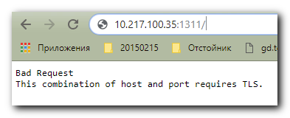

# Need to use https protocol.
https://10.217.100.35:1311/OMSALogin?msgStatus=null
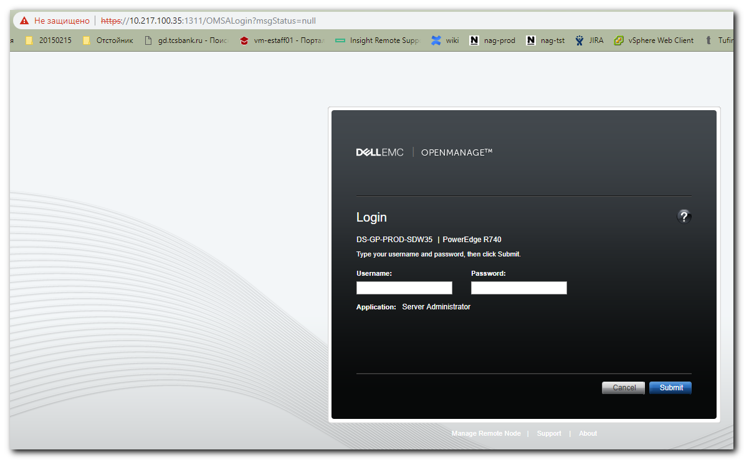

#
# To log in its need to use root password for this server.
# For modern GreenPlum contours need to be used 12345678.
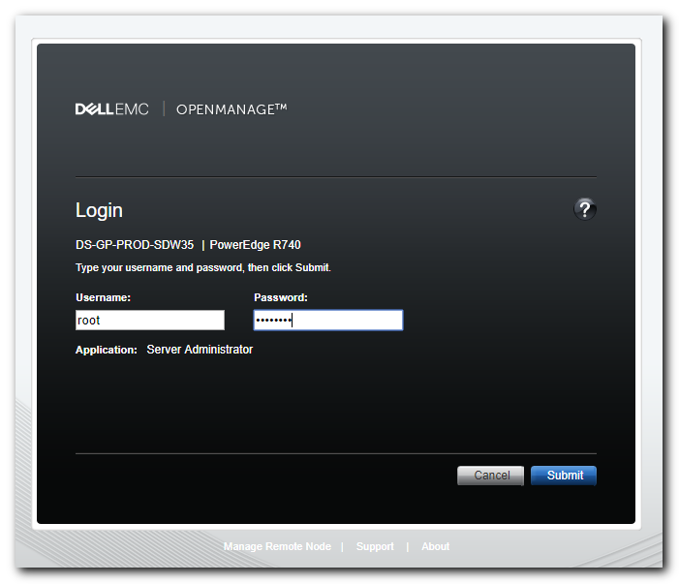

# Same thing available in IE.
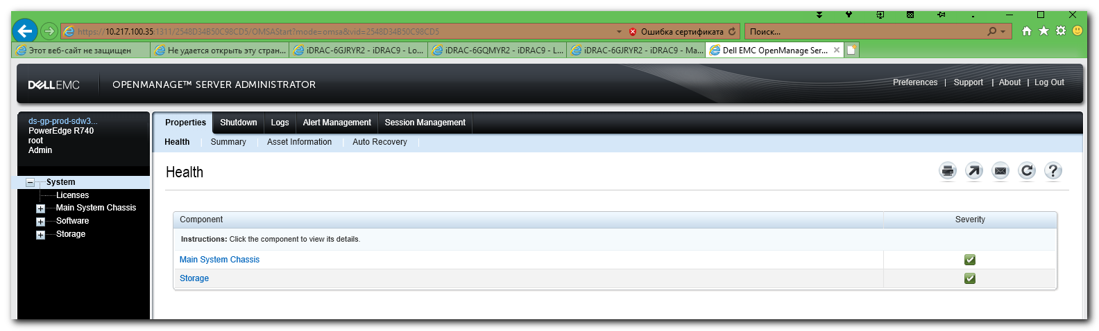

#
# Here is, what usually interesting.
